March 8, 2013
Ankun Fang
This Week:

First week, so we created the fundamental elements of the projects, that is, the math game and the basic visual set ups. Being so simple, it has very few bugs. I worked on the basic HTML to display all the information to the user, while Connor worked on the actual math game. So the menu.html, standardIssue.css,and command.js was created by me, while the file mathQuestionGenerator.js was created by Connor. Menu.html display a menu option, command.js is essentially the brain of the program, where most of the important functions and methods are located there to operate and control the program. standardIssue.css controls the standard style and layout of multiple Web pages all at once.

We started work on the main screen of the game, which is the file screen.html, that being the action screen where most of the action occurs including the math game. The math game has 4 operators, addition, subtraction, multiplication, and division. The action screen has our initial ideas for the distance mechanic being implemented.
Main screen:
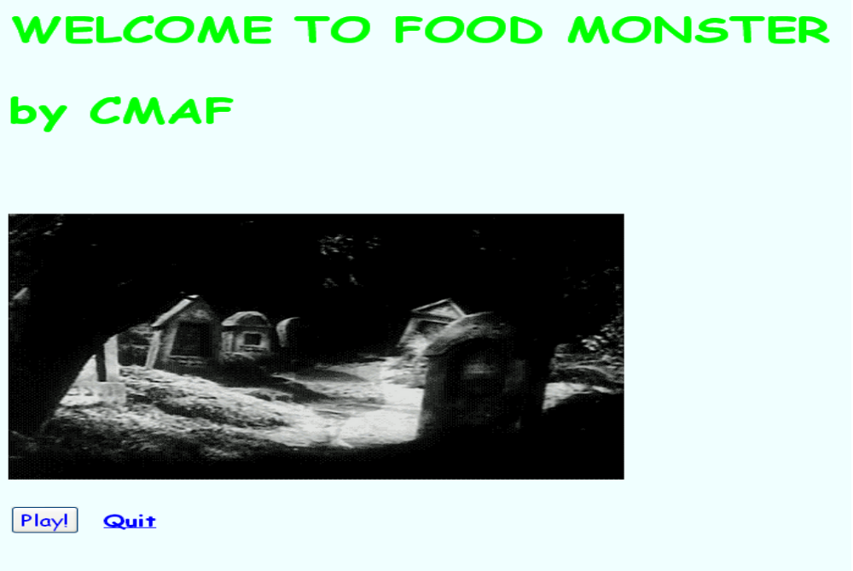

Image of the actual math game
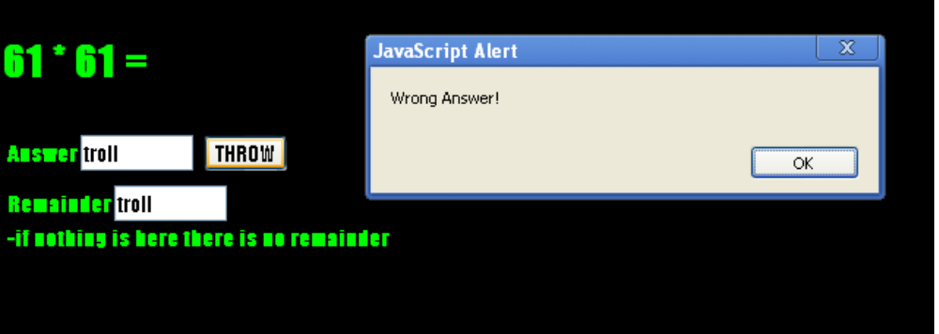
Next week:

Next week, we are going to first get some images ready, and we are going to implement the player and monster into the html. I will need to make my distance function work so that it allows monster to approach the player and enlarge the image as it approaches the player. Then I need to implement what Connor did with the new classes so that our program can be up to date.
We need to make sure that we have the turn function working, and the distance function needs to work. In addition, Connor needs to create the enemy object so that we have something to work with. Then I will add that into my HTML. We might be able to facetime the grade 4's and ask how they like it better.

